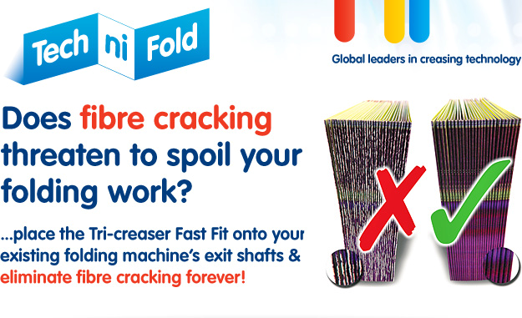
Add your details to this document and send a mail shot to your customer’s & potential customer’s, invite them to ask you questions, just see what response you get, you may be surprised!

